TITLE OF YOUR PAPER (Times New Roman 14, bold, UPPERCASE, center, 42pts before)
AUTHOR 1(Name and Surname)¹, AUTHOR 2² and AUTHOR 3³
¹First author affiliation
²Second author affiliation
³Third author affiliation
corresponding author email:
Abstract. The title, authors, abstract and keywords should be similar to the proposed abstract made on the conference website. If there is no other corresponding author, then this is considered the first author. For two authors use the structure: AUTHOR 1¹ and AUTHOR 2². This paragraph will be formatted as follows: Times New Roman, 10 pts., Justified, Indentation from Left 0.5 cm, Right 0.5 cm, Spacing After 24 pts., Spacing Before 6 pts.
Keywords: 5 keywords, do not repeat the title.

1. Introduction
The paper must have between 4 and 8 pages, font Times New Roman 11, not numbered and written in academic English.
Italic characters must be used only to underline or to emphasize concepts or ideas. The abbreviations must be used only if they have been explained during their first mentioning in the text.
Do not add any text to the headers (do not set running heads) and footers. The references will be mentioned in text and at the end of the paper, and [ ] will be used.
The writing style should be scientific (concise, clear and impersonal).
The Introduction should establish the field and the problem to be tackled, should summarize previous research and introduce present research. The text appearing in figures and tables should be in English. For the text of the paper use Times New Roman, 11 pts.

Page Setup: Paper Size: A4 (21 cm width × 29.7 cm height);
Margins: Top = 2 cm, Bottom = 2 cm, Inside = 2.5cm, Outside = 2 cm, Gutter = 0 cm;
Layout: Header = 1 cm, Footer = 1.5 cm;
Do not use footnotes or endnotes.
2. Structure of the paper (Times New Roman 12 pts, Bold, Left, Hanging 0,5 cm, Before 18 pts, After 6 pts)
The paper is recommended to follow the structure:
1. Introduction
2. Method (experiment, theory, design, model)
3. Results and Discussion
4. Conclusions
Acknowledgements
References
3. Type the Heading of this Section in Here
3.1. Type your subtitle (Times New Roman 11 pts, Bold, Left, Hanging 0,5 cm, Before 12 pts, After 6 pts)
Type the third section of your paper in here.
Tables: included in the text, numbered with Arabic numerals, Times New Roman, 10 pts. Each has as title the word Table, Bold, Centered. Below you may write a caption in Italics, Centered. The exterior lines and those under the head should be double lines.

Table 1
Table Name
Heading | Heading | Heading

Equations style: use equation editor (Cambria Math 11 pts). Equations will be centered and numbered on the right, in round brackets. Please use Equation style (tab 8.25 cm center and 16.5 cm right), centered equation, 6 pt before and after.
$ρ=\frac{m}{V}$ (1)
where: ρ is the density, in g/cm³; ……...

All illustrations, drawings, diagrams, photographs, are called figures and should be all denoted as “Figure”. They are numbered by Arabic numbers (preferably sequentially throughout the paper) Times New Roman, 10 pts., Normal, Centered, Spacing After 8 pts., Spacing Before 11 pts. The figures may be inserted as drawings jpg.

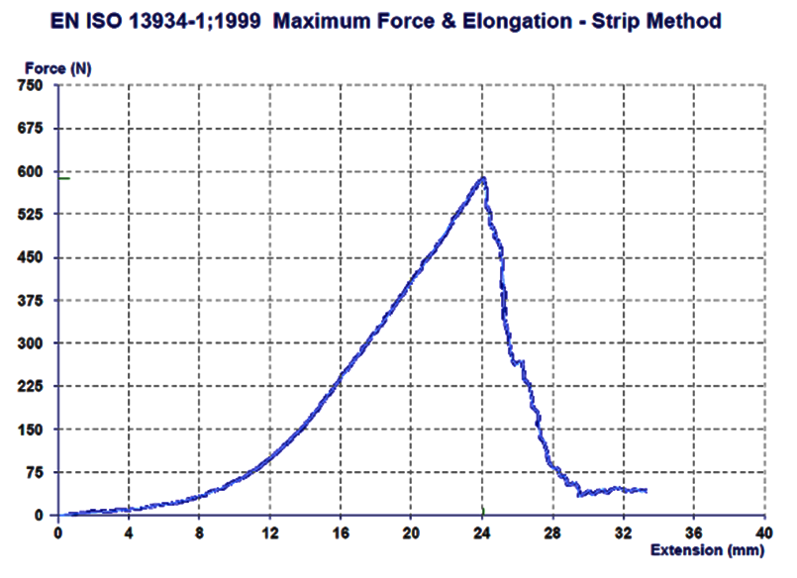
Figure 1 − Figure title.
Acknowledgements. Times New Roman, 10 pts., Normal. The title use Times New Roman, 10 pt., Bold, Spacing After 1 li = 10 pts., Spacing Before 2 li = 22 pts.

References
References use Times New Roman, 9 pts., Normal, Hanging 0,52 cm. Use Times New Roman, 9 pts., Italics for the Titles.

[1] Surname, First name initial and Surname, First name initial, Book title, Publisher, year
[2] Surname, First name initial, “Article title”, in Book, Publisher: City, year, pp. (pages)
[3] Surname, First name initial, Surname, First name initial and Surname, First name initial, Book title, nth ed. Publisher, year. [E-book] Available: .
[4] Surname, First name initial, "Journal paper title", Journal title, vol. , pp. , Jan. year.
[5] Surname, First name initial and Surname, First name initial, "Paper title", eJournal title, vol. , no. , p. , date year. [Online]. Available: [Accessed May 31, 2020].
[6] Surname, First name initial and Surname, First name initial, "Conference Paper title" in Conference volume: Proceedings of the , year, Location, period, year, Publisher, year. pp. .
[7] Surname, First name initial and Surname, First name initial, Conference proceedings paper title, Conference proceeding, Proceedings, Date, Year, Publisher, year.

Recommendations:

Sending the paper: use the surname to identify your paper file, e.g.: surname_ttpf2021_full paper.doc(docx).
For two papers: surname_ttpf2021_full paper1, surname_ttpf2021_full paper2.
Your paper (camera ready) must be submitted to the Editorial Management System: https://ttpf.ro/index.php/publication-2/

Please note that submissions not complying with these guidelines will rejected on formal grounds!

