Partners for 2020 edition
Association of Faculties of Economics from Romania
European Academy of Management and Business Economics
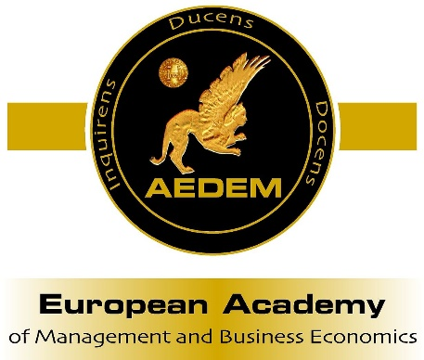
Academy of Economic Studies of Moldova
Romanian National Committee - World Energy Council
Bucharest Chamber of Commerce and Industry
Research Network on Resources Economics and Bioeconomy Association
Gestion y Planificacion Research Group (GESPLAN), Spain
Institute of Agricultural Economics, Belgrade, Serbia
Institute of Economic Sciences, Belgrade, Serbia
Faculty of Social and Cultural Service and Tourism, Stavropol State Agrarian University, Rusia
Faculty of Economics and Business Administration, "St. Kliment Ohridski" University, Sofia, Bulgaria
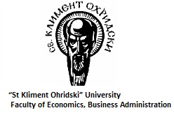
Faculty of Hotel Management and Tourism, University of Kragujevac, Serbia
West University of Timisoara, Romania
