Title of the Paper for the Special Issue
Author Name¹, Co-author Name²
¹Author Affiliation
²Co-author Affiliation
author@university.edu, coauthor@company.com

abstract
The total length of the abstract is limited to 200 words. This part is expected to include a short summary which permits a quick assessment of your topic, your research design, your results and your paper’s relevance to a potential reader. Please use this MS Word file as a template when writing your paper. The recommended number of pages is between 10 and 15. Please note that the maximum page number is 15, including references, appendix, etc., and longer papers WILL NOT BE ACCEPTED. 15 pages mean about 10,000 words for your main text. In addition, when converting Word documents to PDF, one may sometimes come across problems or unwanted changes in the resulting PDF. Therefore, before submitting your final paper in PDF, please check that the format in your paper PDF conforms to this template. Also, page numbers will be added later to the document electronically. Do not make any footers or headers! More details are provided in the following sections.
Key words: Usually between four to eight terms, separated by a comma, all lower-case

- Introduction
Motivation, previous work (Author Year) and the formulation of your own research question.
Citations longer than 40 words (or 4 lines) should be rendered in a free-standing paragraph (0.5 cm inden-tation) with the reference following in a separate line. (Author Year: Page)
Notes are not used for references, should be kept to a minimum and are rendered as footnotes rather than as endnotes. Emphasis should be used sparingly and signalled by italics. Object language data, for instance, your examples, are also presented in italics. Please number your examples and gloss them if necessary:
- Männer bissen Hunde.
man-NOM.PL bite-3PL.PAST dog-ACC.PL
‘men bit dogs’
Please observe the following rules for page and text layout:
- Proceedings will be printed in DIN A4 format. Authors must submit their papers in DIN A4 format.
- Two columns are used except for the title section and for large figures that may need a full-page width.
- Left and right margin are 20 mm each.
- Column width is 80 mm.
- Spacing between columns is 10 mm.
- Top margin is 25 mm (except for the first page which is 30 mm to the title top).
- Bottom margin is 35 mm.
- Text height (without headers and footers) is maximum 235 mm.
- Headers and footers must be left empty.
- Use the font Garamond 10 pt for the main text body. For 1st level headings, use Helvetica 12pt bold face. For 2nd level headings, use Helvetica 10pt bold face. And for 3rd level headings, use Helvetica 10pt, no bold face.
- All text-internal headings of 2nd and 3rd level should be indented with indentation 0.16cm.
- Indentation (0.5cm) is necessary at beginning of a new paragraph, but not for the first paragraph of a new section or after a figure or table.
- Vertical space between text elements should be 15pt.
- Check indentations and spacings by comparing to this example file (in PDF).

- Data and Methods
Description of the way you set up your investigation. The order in which you present participants, data, methods, procedure etc. is up to you, the following is only one possible way to structure the section.
  - Data
The data used/analyzed and motivations for your choice.
  - Methods
The methods chosen and motivations for your choice.
  - Procedure
Data collection/extraction procedures, procedure concerning data analysis and encoding, participant selection etc.
    - Subsubheadings
For ease of orientation, the section can be broken down into yet smaller sections as appropriate.
  - Fonts
It is VERY IMPORTANT that while making the final PDF file, you embed all used fonts! To embed the fonts, you may use the following instructions:
1. For Windows users, the bullzip printer can convert any PDF to have embedded and subsetted fonts.
2. For Linux/Mac users, you may use
pdftops file.pdf
pstopdf -dPDFSETTINGS=/prepress file.pdf
LaTeX users: users should use Adobe Type 1 fonts. Authors must not use Type 3 (bitmap) fonts.
  - Figures, tables and equations
All figures must be centered on the column (or page, if the figure spans both columns). Figure captions should follow each figure and have the format given in Figure 1 below.
Figures should be preferably in gray scale (as some copies of proceedings might also be published in print), but since the proceedings will mainly be published electronically, colored figures can also be used.
Graphics (i.e., illustrations, figures) must not use stipple fill patterns because they will not reproduce properly in Adobe PDF. Please use only SOLID FILL COLORS.
Figures which span 2 columns (i.e., occupy full page width) must be placed at the top or bottom of the page.
An example of a table is shown in Table 1. The caption text must be above the table.

Table 1: This is an example of a table.
 | No. of Scores | Mean | Std. Deviation
Control | 19 | 75.21 | 6.11
Experimental | 19 | 76.05 | 4.74

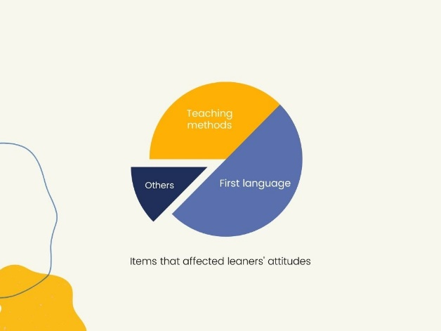
Figure 1: Learner satisfaction chart

Equations should be placed on separate lines and numbered. Examples of equations are given below.
(1)
where is a special warping function
(2)
A residue theorem states that
(3)
Applying (3) to (1), it is quite straightforward to see that

(4)

Finally, we have proven the secret theorem of all speech sciences. No more math is needed to show how useful the result is! If your Word document contains equations, you must not save your Word document from “.docx” to “.doc” because when doing so, Word will convert all equations to images of unacceptably low resolution.
  - Hyperlinks
For technical reasons, the proceedings editor will strip all active links from the papers during processing. Hyperlinks can be included in your paper, if written in full, e.g., “http://www.foo.com/index.html”. The link text must be all black. Please make sure that they present no problems in printing to paper.
  - More information
Please list country names as part of the affiliation for each country. The maximum number of authors in the author list is twenty. If the number of contributing authors is more than twenty, they should be listed in a footnote or in acknowledgement section, as appropriate.
Authors are requested to submit PDF files of their manuscripts. You can use commercially available tools or for instance http://www.pdfforge.org/products/pdfcreator. The PDF file should comply with the following requirements: (a) there must be no PASSWORD protection on the PDF file at all; (b) all fonts must be embedded; and (c) the file must be text searchable (do CTRL-F and try to find a common word such as ‘the’). The proceedings editors will contact authors of non-complying files to obtain a replacement. In order not to endanger the preparation of the proceedings, papers for which a replacement is not provided in a timely manner will be withdrawn.
- Results
Report of the obtained results:
Case | Category A | Category B | Similarity
1 | Apple | Pear | 0
2 | Pear | Apple | .72
Table 2. Main results
- Discussion
Critical assessment of possible explanations of your results.
- Conclusion
Evaluation of your research question and consideration of its wider implications.
- Acknowledgments
Note to authors: Authors should not use logos in the acknowledgement section; rather authors should acknowledge corporations by naming them only.
- References
References should be NUMBERED in the main text body in order of appearance, for example [1], [2], [3, pp. 417–422], and [4].

The list of references should be formatted according to the APA FORMAT. For example:

Author's last name, initial(s). & author's last name, initials. (Year published). Title of the published material. Proc. XXth... or Journal of..., page-page.

Please use 10pt Garamond. All literature references should be prefixed by the corresponding number in the text. The list indentation is 0.63 cm. For more details, please visit: https://www.mendeley.com/guides/apa-citation-guide or look at the following website for additional example: https://libguides.murdoch.edu.au/APA/sample. Please also note the examples provided below for (1) journal, (2) proceedings, (3) e-journal, (4) book, (5) chapter.
- Borman, W. C., Hanson, M. A., Oppler, S. H., Pulakos, E. D., & White, L. A. (1993). Role of early supervisory experience in supervisor performance. Journal of Applied Psychology, 78, 443-449.
- Borman, W. C., Hanson, M. A., Oppler, S. H., Pulakos, E. D., & White, L. A. (1993). Role of early supervisory experience in supervisor performance. Proc 13th Conference of cognitive psychology, Madrid, Spain, 443-449.
- March, E., & Springer, J. (2019). Belief in conspiracy theories: The predictive role of schizotypy, Machiavellianism, and primary psychopathy. PLoS One, 14(12): Article e0225964.
- Newcomb, H. (Ed.). (2000). Television: The critical view (6th ed). Oxford University Press.
- Payne, S. (1976). 'Dangerous and different': reconstructions of madness in the 1990s and the role of mental health policy. In Watson, S. & L. Doyal (eds.), Engendering social policy (pp.180-195). City: XX University Press.

This is really more convenient than flipping to the end each time.

